R Programs
- Write a program to get the first 10 Fibonacci numbers
In [4]:

Fibonacci <- numeric(10)
Fibonacci[1] <- Fibonacci[2] <- 1
for (i in 3:10) Fibonacci[i] <- Fibonacci[i - 2] + Fibonacci[i - 1]
print("First 10 Fibonacci numbers:")
print(Fibonacci)

OutPut:
[1] "First 10 Fibonacci numbers:"
[1] 1 1 2 3 5 8 13 21 34 55

- Write a program to find the factors of a given number
print_factors = function(n) {
print(paste("The factors of",n,"are:"))
for(i in 1:n) {
if((n %% i) == 0) {
print(i)
}
}
}
print_factors(4)
print_factors(7)
print_factors(12)

Output:

[1] "The factors of 4 are:"
[1] 1
[1] 2
[1] 4
[1] "The factors of 7 are:"
[1] 1
[1] 7
[1] "The factors of 12 are:"
[1] 1
[1] 2
[1] 3
[1] 4
[1] 6
[1] 12

- Write a program to find the maximum and the minimum value of a given vector
In [9]:

nums = c(10, 20, 30, 40, 50, 60)
print('Original vector:')
print(nums)
print(paste("Maximum value of the said vector:",max(nums)))
print(paste("Minimum value of the said vector:",min(nums)))

OutPut:

[1] "Original vector:"
[1] 10 20 30 40 50 60
[1] "Maximum value of the said vector: 60"
[1] "Minimum value of the said vector: 10"

4) Write a program to create three vectors numeric data, character data and logical data. Display the content of the vectors and their type.
In [14]:

a = c(1, 2, 5, 3, 4, 0, -1, -3)
b = c("Red", "Green", "White")
c = c(TRUE, TRUE, TRUE, FALSE, TRUE, FALSE)
print(a)
print(typeof(a))
print(b)
print(typeof(b))
print(c)
print(typeof(c))

Output:

[1] 1 2 5 3 4 0 -1 -3
[1] "double"
[1] "Red" "Green" "White"
[1] "character"
[1] TRUE TRUE TRUE FALSE TRUE FALSE
[1] "logical"

- Write a R program to create an array, passing in a vector of values and a vector of dimensions. Also provide names for each dimension.

a = array(
6:30,
dim = c(4, 3, 2),
dimnames = list(
c("Col1", "Col2", "Col3", "Col4"),
c("Row1", "Row2", "Row3"),
c("Part1", "Part2")
)
)
print(a)

OutPut:

Part1

Row1 Row2 Row3
Col1 6 10 14
Col2 7 11 15
Col3 8 12 16
Col4 9 13 17

, , Part2

Row1 Row2 Row3
Col1 18 22 26
Col2 19 23 27
Col3 20 24 28
Col4 21 25 29

- Write a R program to create an array with three columns, three rows, and two "tables", taking two vectors as input to the array. Print the array.
In [2]:

v1 = c(1, 3, 5, 7)
v2 = c(2, 4, 6, 8, 10)
arra1 = array(c(v1, v2),dim = c(3,3,2))
print(arra1)

OUTPUT:

[,1] [,2] [,3]
[1,] 1 7 6
[2,] 3 2 8
[3,] 5 4 10

[,1] [,2] [,3]
[1,] 1 7 6
[2,] 3 2 8
[3,] 5 4 10

- Create a list of elements using vectors, matrices and a functions. Print the content of the list.
In [1]:

l = list(
c(1, 2, 2, 5, 7, 12),
month.abb,
matrix(c(3, -8, 1, -3), nrow = 2),
asin
)
print("Content of the list:")
print(l)

OUTPUT:

[1] "Content of the list:"
[[1]]
[1] 1 2 2 5 7 12

[[2]]
[1] "Jan" "Feb" "Mar" "Apr" "May" "Jun" "Jul" "Aug" "Sep" "Oct" "Nov" "Dec"

[[3]]
[,1] [,2]
[1,] 3 1
[2,] -8 -3

[[4]]
function (x) .Primitive("asin")

- Write a R program to create a simple bar plot of five subjects marks.
In [3]:

marks = c(70, 95, 80, 74)
barplot(marks,
main = "Comparing marks of 5 subjects",
xlab = "Marks",
ylab = "Subject",
names.arg = c("English", "Science", "Math.", "Hist."),
col = "darkred",
horiz = FALSE)

OUTPUT:

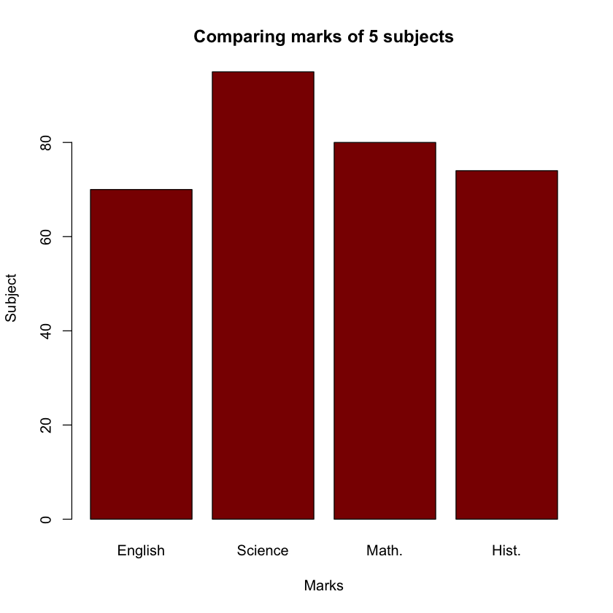

Write a script that will print 'Is a Matrix' if the variable x is a matrix, otherwise print "Not a Matrix". Hint: You may want to check out help(is.matrix)
In [3]:

x <- matrix()

if (is.matrix(x)){
print('Is a Matrix')
}else{
print("Not a Matrix")
}
OUTPUT:
[1] "Is a Matrix"

Write a script that uses if,else if, and else statements to print the max element in a numeric vector with 3 elements.
In [5]:

x <- c(20, 10, 1)

if (x[1] > x[2] & x[1] > x[3] ) {
print(x[1] )
} else if (x[2] > x[3] ) {
print(x[2])
} else {
print(x[3])
}
OUTPUT:
[1] 20

Write a script that will print "Even Number" if the variable x is an even number, otherwise print "Not Even":
In [2]:

x <- 3 # Change x to test

if (x%%2 == 0){
print('Even Number')
}else{
print('Not Even')
}
OUTPUT:
[1] "Not Even"

R Programming: Vector Exercise 4

Write a R program to convert given dataframe column(s) to a vector.
In [1]:

dfc1 = c(1, 2, 3, 4, 5)
dfc2 = c(6, 7, 8, 9, 10)
dfc3 = c(11, 12, 13, 14, 15)
dfc4 = c(16, 17, 18, 19, 20)
v <- data.frame(dfc1=1:5, dfc2=6:10, dfc3=11:15, dfc4=16:20)
print(v)
OUTPUT:
dfc1 dfc2 dfc3 dfc4
1 1 6 11 16
2 2 7 12 17
3 3 8 13 18
4 4 9 14 19
5 5 10 15 20

Write a R program to extract every nth element of a given vector.
In [2]:
v <- 1:100
print("Original vector:")
print(v)
print("After extracting every 5th element of the said vector:")
n <- v[seq(1, length(v), 5)]
print(n)

[1] "Original vector:"
[1] 1 2 3 4 5 6 7 8 9 10 11 12 13 14 15 16 17 18
[19] 19 20 21 22 23 24 25 26 27 28 29 30 31 32 33 34 35 36
[37] 37 38 39 40 41 42 43 44 45 46 47 48 49 50 51 52 53 54
[55] 55 56 57 58 59 60 61 62 63 64 65 66 67 68 69 70 71 72
[73] 73 74 75 76 77 78 79 80 81 82 83 84 85 86 87 88 89 90
[91] 91 92 93 94 95 96 97 98 99 100
[1] "After extracting every 5th element of the said vector:"
[1] 1 6 11 16 21 26 31 36 41 46 51 56 61 66 71 76 81 86 91 96

Write a program to list the distinct values in a vector from a given vector.
In [1]:

v = c(10, 10, 10, 20, 30, 40, 40, 40, 50)
print("Original vector:")
print(v)
print("Distinct values of the said vector:")
print(unique(v))
OUTPUT:
[1] "Original vector:"
[1] 10 10 10 20 30 40 40 40 50
[1] "Distinct values of the said vector:"
[1] 10 20 30 40 50

Write a program to find the elements of a given vector that are not in another given vector.

a = c(0, 10, 10, 10, 20, 30, 40, 40, 40, 50, 60)
b = c(10, 10, 20, 30, 40, 40, 50)
print("Original vector-1:")
print(a)
print("Original vector-2:")
print(b)
print("Elements of a that are not in b:")
result = setdiff(a, b)
print(result)
OUTPUT:
[1] "Original vector-1:"
[1] 0 10 10 10 20 30 40 40 40 50 60
[1] "Original vector-2:"
[1] 10 10 20 30 40 40 50
[1] "Elements of a that are not in b:"
[1] 0 60
In [ ]:
- Write a R program to access the last value in a given vector.
In [1]:

x = c(10, 20, 30, 20, 20, 25, 9, 26)
print("Original Vectors:")
print(x)
print("Access the last value of the said vector:")
print(tail(x, n=1))

OUTPUT:
[1] "Original Vectors:"
[1] 10 20 30 20 20 25 9 26
[1] "Access the last value of the said vector:"
[1] 26

17) Write a R program to find nth highest value in a given vector.
x = c(10, 20, 30, 20, 20, 25, 9, 26)
print("Original Vectors:")
print(x)
print("nth highest value in a given vector:")
print("n = 1")
n = 1
print(sort(x, TRUE)[n])
print("n = 2")
n = 2
print(sort(x, TRUE)[n])
print("n = 3")
n = 3
print(sort(x, TRUE)[n])
print("n = 4")
n = 4
print(sort(x, TRUE)[n])

OUTPUT:
[1] "Original Vectors:"
[1] 10 20 30 20 20 25 9 26
[1] "nth highest value in a given vector:"
[1] "n = 1"
[1] 30
[1] "n = 2"
[1] 26
[1] "n = 3"
[1] 25
[1] "n = 4"
[1] 20

R Program to Make a Simple Calculator

Example: Simple Calculator in R
# Program make a simple calculator
# that can add, subtract, multiply
# and divide using functions

add <- function(x, y) {
return(x + y)
}

subtract <- function(x, y) {
return(x - y)
}

multiply <- function(x, y) {
return(x * y)
}

divide <- function(x, y) {
return(x / y)
}

# take input from the user
print("Select operation.")
print("1.Add")
print("2.Subtract")
print("3.Multiply")
print("4.Divide")

choice = as.integer(readline(prompt="Enter choice[1/2/3/4]: "))

num1 = as.integer(readline(prompt="Enter first number: "))
num2 = as.integer(readline(prompt="Enter second number: "))

operator <- switch(choice,"+","-","*","/")
result <- switch(choice, add(num1, num2), subtract(num1, num2), multiply(num1, num2), divide(num1, num2))

print(paste(num1, operator, num2, "=", result))
Output
[1] "Select operation."
[1] "1.Add"
[1] "2.Subtract"
[1] "3.Multiply"
[1] "4.Divide"
Enter choice[1/2/3/4]: 4
Enter first number: 20
Enter second number: 4
[1] "20 / 4 = 5"
In this program, we ask the user to choose the desired operation. Options 1, 2, 3 and 4 are valid.
Two numbers are taken from the user and a switch branching is used to execute a particular function.
User-defined functions add(), subtract(), multiply() and divide() evaluate respective operations.

R Program to Check for Leap Year
A leap year is exactly divisible by 4 except for century years (years ending with 00). The century year is a leap year only if it is perfectly divisible by 400.

Example: Check Leap Year
# Program to check if
# the input year is
# a leap year or not

year = as.integer(readline(prompt="Enter a year: "))
if((year %% 4) == 0) {
if((year %% 100) == 0) {
if((year %% 400) == 0) {
print(paste(year,"is a leap year"))
} else {
print(paste(year,"is not a leap year"))
}
} else {
print(paste(year,"is a leap year"))
}
} else {
print(paste(year,"is not a leap year"))
}
Output 1
Enter a year: 1900
[1] "1900 is not a leap year"
Output 2
Enter a year: 2000
[1] "2000 is a leap year"
If a year is divisible by 4, 100 and 400, it's a leap year.
If a year is divisible by 4 and 100 but not divisible by 400, it's not a leap year.
If a year is divisible by 4 but not divisible by 100, it's a leap year.
If a year is not divisible by 1, it's not a leap year.
This logic is implemented in the above program using nested if...else statement.

R Program to Reorder Columns in a Dataframe

Example 1: Reorder R Dataframe Columns Using Column Name
# import dplyr package
library(dplyr)

# Create a data frame
dataframe1 <- data.frame (
Age = c(22, 15, 19),
Address = c("Nepal", "USA", "Germany"),
Name = c("Juan", "Alcaraz", "Simantha")
)

# rearrange columns in Name, Age, Address order
print(select(dataframe1, Name, Age, Address))
Output
Name Age Address
1 Juan 22 Nepal
2 Alcaraz 15 USA
3 Simantha 19 Germany
In the above example, we have used the select() function provided by the dplyr package to reorder columns of the dataframe named dataframe1.
select(dataframe1, Name, Age, Address)
Here, inside select(),
- dataframe1 - a dataframe whose column is to be reordered
- Name, Age, Address - new order of columns
Hence the order of dataframe1 column is changed from Age, Address, Name to Name Age Address.

Example 2: Reorder R Dataframe Columns by Column Position
# import dplyr package
library(dplyr)

# Create a data frame
dataframe1 <- data.frame (
Age = c(22, 15, 19),
Address = c("Nepal", "USA", "Germany"),
Name = c("Juan", "Alcaraz", "Simantha")
)

# rearrange columns in Name, Age, Address order
print(select(dataframe1, 3, 1, 2))
Output
Name Age Address
1 Juan 22 Nepal
2 Alcaraz 15 USA
3 Simantha 19 Germany
In the above example, we have used the column position inside select() to reorder columns of dataframe1.
select(dataframe1, 3, 1, 2)
Here, the 3rd column is now 1st column, 1st column is now 2nd column and 2nd column is now 3rd column.

R Program to Convert Factors to Characters

Example: Convert Factors to Characters in R
factor1 <- factor(c("Male", "Female", "Transgender"))

# convert factor to character
result <- as.character(factor1)

print(result)
Output
[1] "Male" "Female" "Transgender"
In the above example, we have used the as.character() function to convert the factor named factor1 to character.
As we can see, each element of factor1 is displayed separately as a character.

R Program to Convert a List to a Dataframe

Example 1: Convert List to Dataframe in R
# create a list
list1 <- list(A = c("Sabby", "Cathy", "Dormy"),
B = c(18, 24, 22),
C = c("Computer Science", "Engineering", "Business")
)

# convert list to dataframe
result <- as.data.frame(list1)

print(result)
Output
A B C
1 Sabby 18 Computer Science
2 Cathy 24 Engineering
3 Dormy 22 Business
In the above example, we have used the as.data.frame() function to convert the list named list1 to dataframe.
First, the names of the list A, B, C are converted to dataframe columns and finally all the list elements are added in each column respectively.

Example 2: Change Column Names While Convert to R Dataframe
In R, we pass the col.names parameter to change the name of the column. For example,
# create a list
list1 <- list(A = c("Sabby", "Cathy", "Dormy"),
B = c(18, 24, 22),
C = c("Computer Science", "Engineering", "Business")
)

# convert list to dataframe and change name of column
result <- as.data.frame(list1,
col.names = c("Name", "Age", "Course")
)

print(result)
Output
Name Age Course
1 Sabby 18 Computer Science
2 Cathy 24 Engineering
3 Dormy 22 Business
In the above example, we have passed the col.names parameter to the as.data.frame() function to change the name of each column.
result <- as.data.frame(list1,
col.names = c("Name", "Age", "Course")
)
Here, the list name
- A in changed to "Name"
- B in changed to "Age"
- C in changed to "Course"

R Program to Combine Two Dataframe into One
We use the rbind() and the cbind() functions to combine two data frames together in R.
- rbind() - combines two data frames vertically
- cbind() - combines two data frames horizontally

Example 1: Combine Dataframe Vertically Using rbind() in R
If we want to combine two data frames vertically, the column name of the two data frames must be the same. For example,
# create a data frame
dataframe1 <- data.frame (
Name = c("Juan", "Alcaraz"),
Age = c(22, 15)
)

# create another data frame
dataframe2 <- data.frame (
Name = c("Yiruma", "Bach", "Ludovico"),
Age = c(46, 89, 72)
)

# combine two data frames vertically
updated <- rbind(dataframe1, dataframe2)
print(updated)
Output
Name Age
1 Juan 22
2 Alcaraz 15
3 Yiruma 46
4 Bach 89
5 Ludovico 72
In the above example,we have created a dataframe named dataframe1, with two elements for both the columns and dataframe2, with three elements for both the columns.
And we have combined them together vertically using rbind().
Since we want to combine two data frames vertically, we have provided the same column name Name and Age for both the data frames.

Example 2: Combine Dataframe Horizontally Using cbind() in R
The cbind() function combines two or more data frames horizontally. For example,
# create a data frame
dataframe1 <- data.frame (
Name = c("Juan", "Alcaraz"),
Age = c(22, 15)
)

# create another data frame
dataframe2 <- data.frame (
Hobby = c("Tennis", "Piano")
)

# combine two data frames horizontally
updated <- cbind(dataframe1, dataframe2)
print(updated)
Output
Name Age Hobby
1 Juan 22 Tennis
2 Alcaraz 15 Piano
Here, we have used cbind() to combine two data frames: dataframe1 and dataframe2 horizontally.
And finally the combined dataframe which is stored in the updated variable is printed.
Note: The number of items on each vector of two or more combining data frames must be equal otherwise we will get an error: arguments imply differing number of rows or columns.

